Assignment - 10
Task - 1
Description: Refactor Nested Conditionals
Task: Provide AI with the following nested conditional code and ask it to simplify and refactor for readability.
Python script.
def discount(price, category):
if category == "student":
if price > 1000:
return price * 0.9
else: return price * 0.95
else:
if price > 2000:
return price * 0.85
else:
return price
Prompt: Refactor the following nested conditional code to make it cleaner and more readable. You may use simplified logic, dictionaries, or helper functions.
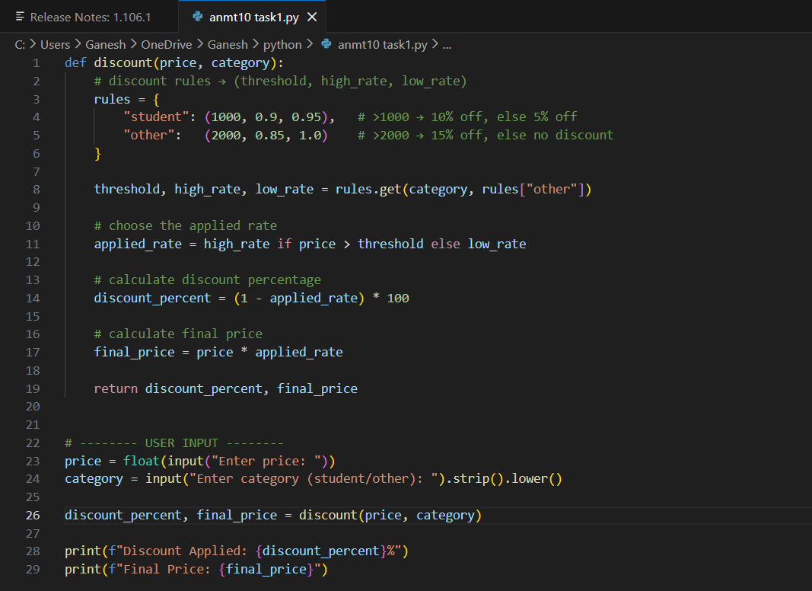
Expected Output: Refactored code using cleaner logic, possibly a dictionary or separate helper functions.
Practical Output:

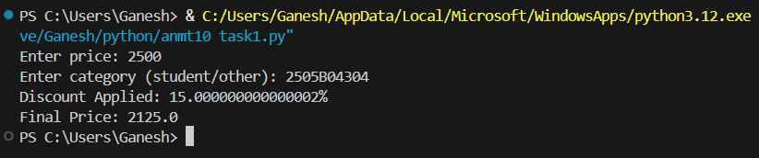

Task - 2
Description: Optimize Redundant Loops
Task: Give AI this messy loop and ask it to refactor and optimize.
Python script.
def find_common(a, b):
res = []
for i in a:
for j in b:
if i == j:
res.append(i)
return res
Prompt: Write a Python program where the user enters two lists. Then optimize the function find_common(a, b) that currently uses nested loops. Refactor it to a cleaner and faster version using sets (set(a) & set(b)). Show both the original and optimized outputs.

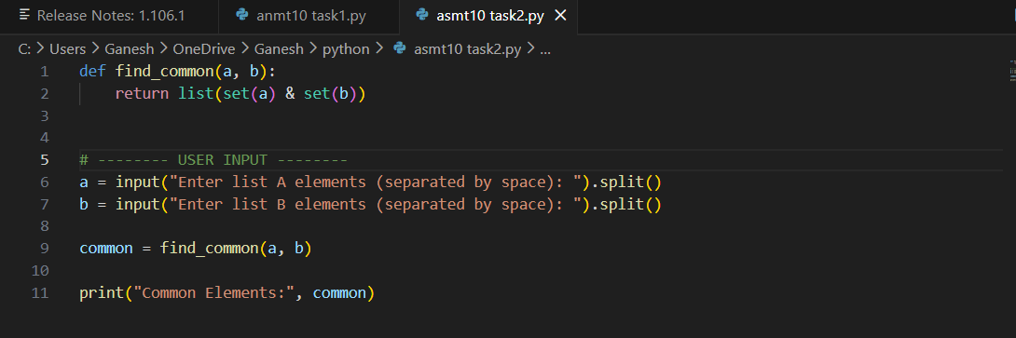
Expected Output: Cleaner version using Python sets (set(a) & set(b))
Practical Output:

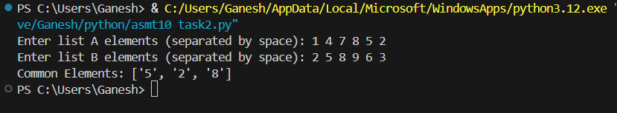

Task - 3
Description: Improve Class Design
Task: Provide this class with poor readability and ask AI to improve:
• Naming conventions
• Encapsulation
• Readability & maintainability
Python Script:
class emp:
def __init__(self,n,s):
self.n=n
self.s=s
def inc(self,p):
self.s=self.s+(self.s*p/100)
def pr(self):
print("emp:",self.n,"salary:",self.s)

Prompt: Write a Python program where the user enters an employee name and salary. Use this poorly written class and improve it:
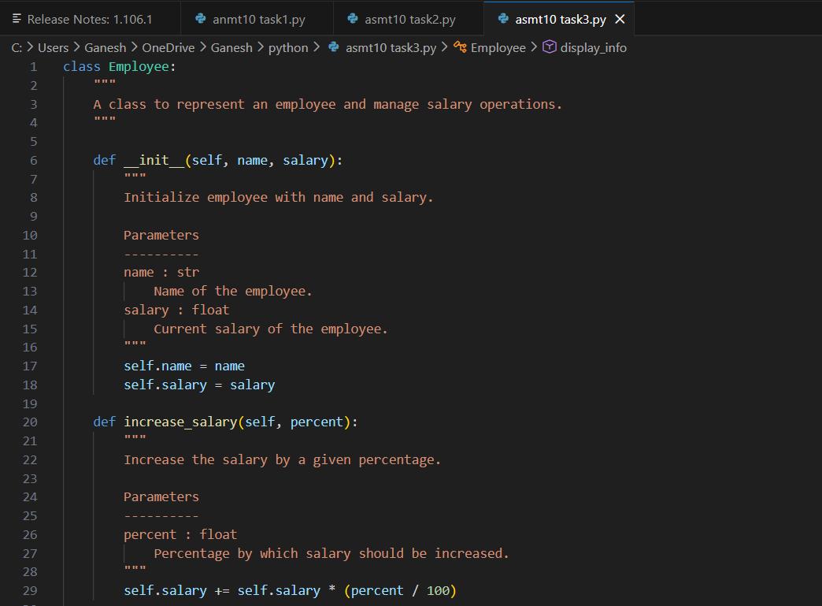
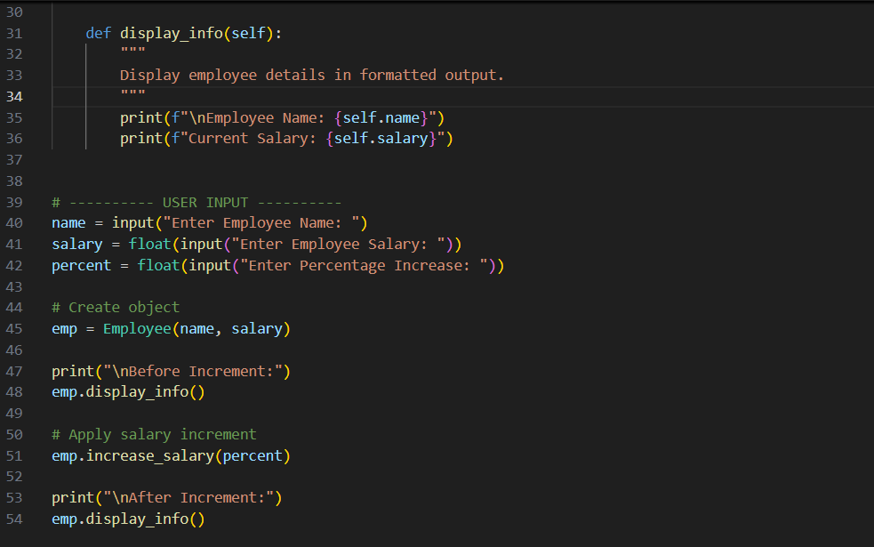

Expected Output: Employee class with meaningful methods (increase_salary, display_info), formatted output, and added docstrings
Practical Output:

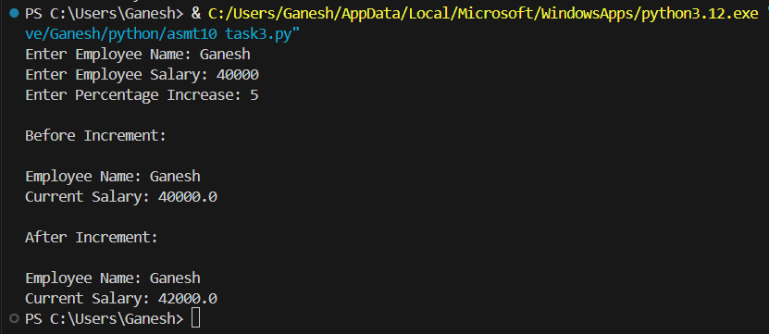

Task - 4
Description: Modularize Long Function
Task: Give AI this long unstructured function and let it modularize into smaller helper functions.
Python Script
def process_scores(scores):
total = 0
for s in scores:
total += s
avg = total / len(scores)
highest = scores[0]
for s in scores:
if s > highest:
highest = s
lowest = scores[0]
for s in scores:
if s < lowest:
lowest = s
print("Average:", avg)
print("Highest:", highest)
print("Lowest:",lowest)
Prompt: Take user input for a list of scores and refactor the process_scores() function by splitting it into helper functions: calculate_average(), find_highest(), and find_lowest(). Then rewrite the main function using these helpers.

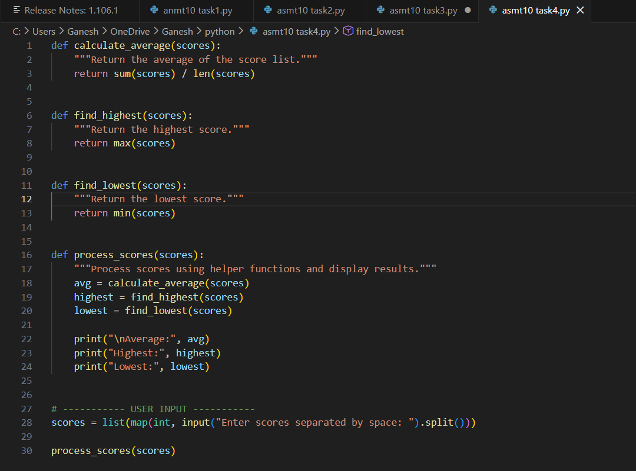

Expected Output:
• Split into functions: calculate_average, find_highest, find_lowest.
• Clean main process_scores() using helper functions
Practical Output:

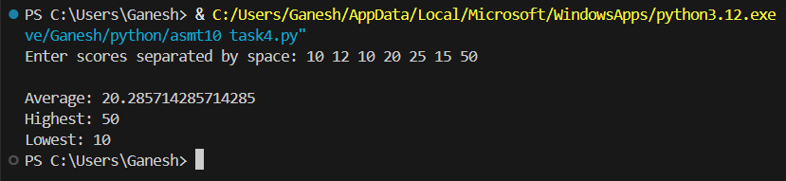

Task - 5
Description: Code Review on Error Handling
Task: Provide AI with this faulty code and ask it to improve error handling, naming, and readability.
Python Script
def div(a,b):
return a/b
print(div(10,0))
Prompt: Improve this code by adding error handling, better naming, and a docstring

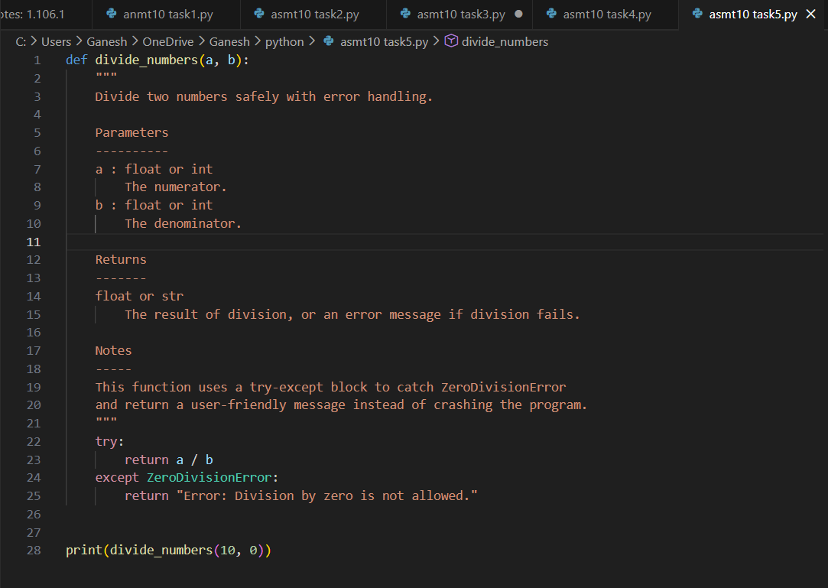

Expected Output:
• Function with proper error handling using try-except.
• Better naming (divide_numbers).
• AI-generated docstring explaining error handling.
Practical Output:

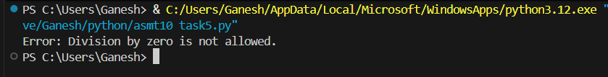

Task - 6
Description: Complexity Reduction
Task: Use AI to simplify overly complex logic.
Sample Input Code:
def grade(score):
if score >= 90:
return "A"
else:
if score >= 80:
return "B"
else:
if score >= 70:
return "C"
else:
if score >= 60:
return "D"
else:
return "F"
Prompt: Write a Python program that takes user input for score and simplifies the nested grade() function. Replace the deep nested if-else structure with cleaner logic using elif or a dictionary
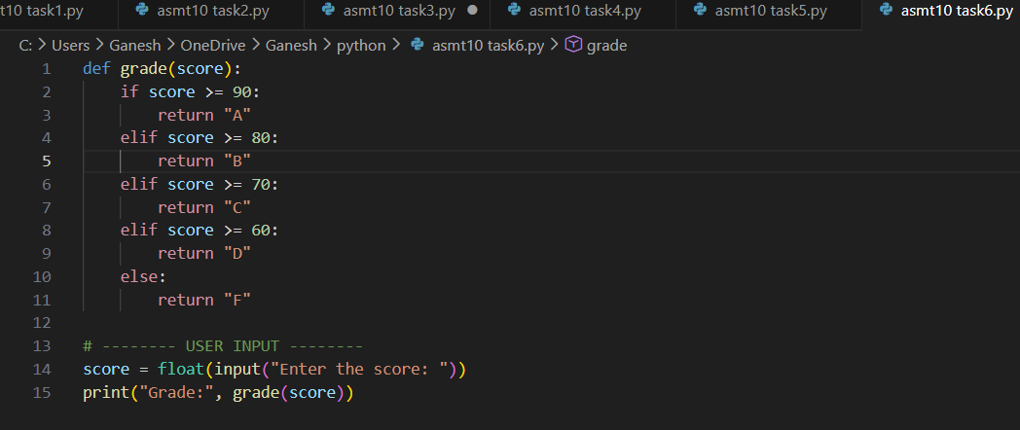

Expected Output: Cleaner logic using elif or dictionary mapping
Practical Output:

